Jacob Ciurca

Dr. Lu

Lab 10

Cosc 350

11/26/2020

**Pre-Lab:** Reviewed what we learned about graphs as well as performed BFS and DFS on graph B which you can find in the main function

**Lab:**

**Lab_10.cpp:**

#include <iostream>

#include "d_graph.h"

#include "d_util.h"

#include <list>

#include <set>

#include <fstream>

using namespace std;

int main()

{

graph<string> g;

ifstream data;

data.open("graphB.dat");

int vertex;

int edge;

string a;

string e1;

string e2;

int e3;

data >> vertex;

for(int i=0; i<vertex; i++){

data >> a;

g.insertVertex(a);

}

data >> edge;

for(int i=0; i<edge; i++){

data >> e1;

data >> e2;

data >> e3;

g.insertEdge(e1, e2, e3);

}

cout << "Here is your starting graph" << endl;

cout << g;

cout << "Performing BFS on graph g\n";

set<string> s;

s = bfs(g, "A");

writeContainer(s.begin(), s.end(), " ");

cout << endl;

list<string> l;

cout << "Performing DFS on graph g\n";

dfs(g, l);

writeContainer(l.begin(), l.end(), " ");

cout << endl;

cout << "Please enter a vertex to add to the graph\n";

string ver;

cin >> ver;

g.insertVertex(ver);

cout << "Performing BFS on graph from new vertex to display set of reachable vertices\n";

s = bfs(g, ver);

writeContainer(s.begin(), s.end(), " ");

cout << endl;

cout << "Performing DFS on new graph giving vertices in reverse order of their finishing times\n";

dfs(g, l);

writeContainer(l.begin(), l.end(), " ");

return 0;

}

**GraphB.dat:**

6

A B C D E F

10

A B 5

B A 5

B C 2

C B 2

C D 7

A D 15

A F 20

F E 3

E F 3

D F 3

**Sample Output:**

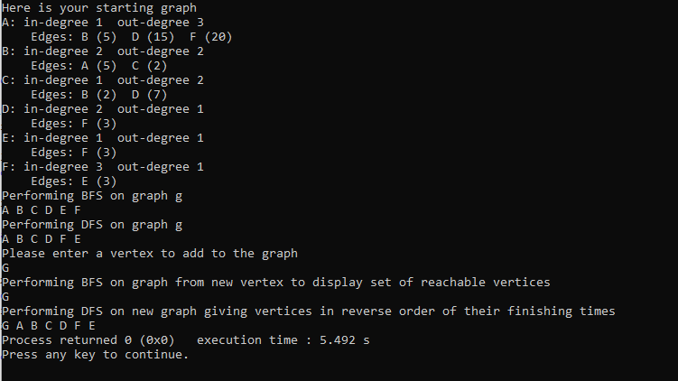

**Post-Lab:** This lab was good at giving us practice with BFS and DFS searches as well as giving us more practice with graphs. This lab took me around 1 hour 45 minutes to complete and I did this lab by myself with no help